World Cup 2022: TACBIS publishes research into prevalence of colour blindness in elite footballers, finding at least one player in every male squad
Press Release 10th November 2022
Embargoed until 14th November 2022

New research finds six percent of male footballers playing at elite level have a form of colour vision deficiency (colour blindness, CVD), equivalent to 1.5 players in each male squad of 25.

The TACBIS* project investigated the prevalence of colour blindness in elite football by screening players in clubs and National teams in several countries and demonstrated that 6% have some degree of colour vision deficiency. In most cases neither the player nor their club/National Association were previously aware.

The TACBIS project was created to raise awareness of colour blindness in sport, identify prevalence, challenges and barriers to progression and to recommend solutions. Over the course of the project, elite footballers playing at Under 18 level or above for club and/or National teams (in Portugal, Denmark and UK) were screened for colour vision deficiency. At least one colour blind player was found in every team screened for the research.

This unique research project also demonstrated
- lack of knowledge of the condition amongst coaching staff and management
- colour blindness can impact both individual player and team performance
- there are simple solutions which can remove most challenges
- the need for further amendments to and implementation of kit regulations across leagues/ competitions

The publication of this information is particularly relevant prior to the start of the 2022 FIFA World Cup where, extrapolating these results, it can be reasonably expected there will be approximately 50 colour blind players amongst 32 squads of 26 players. One is already well known – Thomas Delaney from the Danish National team.

Kathryn Albany-Ward, CEO of Colour Blind Awareness said

We have long been keen to demonstrate the prevalence of colour blindness in elite footballers to ensure the football industry takes their needs seriously. Doing so will also benefit millions of colour blind fans and could not only result in better return on financial investments (from individual players) but also in increased revenue for the sport, as with less kit ‘clashes’ more fans will want to watch football.

There should be no need for all individual affected players to be identified since, with proper buy-in from coaches, clubs, management and competition organisers, simple changes can be made which will remove most barriers.

I already knew of three players with colour blindness at the World Cup in 2002 who played in different teams and against each other. Pretending that colour blind players don’t exist at elite level in significant numbers is no longer an option for elite sport.’

On publication of this ground-breaking research Dr Adam Bibbey, Senior lecturer in Sport and Exercise Psychology, Oxford Brookes University said ‘Our results have demonstrated that approximately 25% of colour blind players are not making it to elite level, which is a problem for football as it represents wasted time and financial investment of academies and negative career and mental health implications for players. Colour blind players have indicated that they do not feel as though they can speak out about their challenges for fear of embarrassment or detrimental impact on contract negotiations. Elite colour blind players have also outlined the detrimental impact on training and match day performance due to difficult combinations of kits and bibs or incorrect use of equipment. These barriers can be easily addressed.’

Francisca Araújo of Federaçao Portuguesa de Futbol’s Social Intervention Unit commented ‘The most important legacy from this project for us is to ensure that we know which of our players are affected so that we can provide proper support.’

From Danish Superliga club Randers FC, Chief Executive Henrik Jørgensen observed ‘Our club and our affected players themselves, were surprised to find from the screening that we had two colour blind players in our first team, even though we were aware beforehand that statistically that would be the case. We have taken note of the results of this exercise and will try to adapt our training materials accordingly in the future’ and Michael Møller Højfeldt, Data and Ticketing Manager added ‘In addition, we have reviewed our ticket system and adjusted it so that it also appears user-friendly for customers with colour blindness

The TACBIS project partners will be holding a panel session ‘Prevalence of colour blindness amongst players and the implications for elite sport’ on 14th November in Budapest, Hungary where the findings will be discussed in more detail, including implications for rugby and other sports.

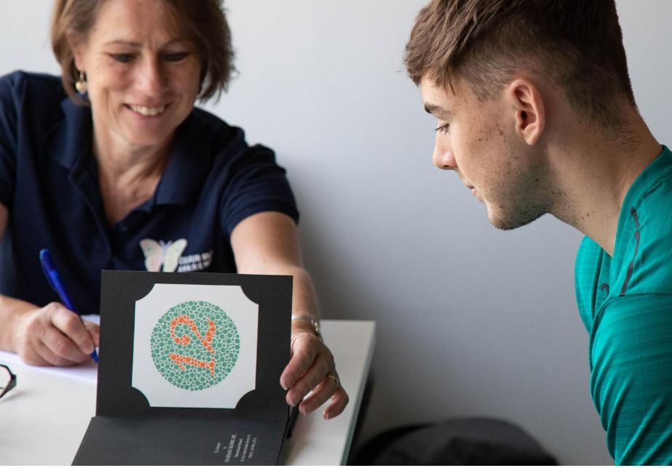
Swansea City AFC, Pre-season screening, 22/23 season

Statistics
- Colour vision deficiency (CVD) affects 1 in 12 males (8%) and 1 in 200 females in the general population
- 300 million people worldwide (Europe 34m, UK 3m) inherit colour blindness
- The condition affects ability to distinguish between many combinations of colours, not just reds and greens

*TACBIS Project www.tacbis.eu @TACBISproject
A Collaborative Partnership comprising the National Football Associations of Iceland, Portugal and Romania, Danish Superliga club Randers FC, The European Football Development Network (EFDN), Oxford Brookes University and Colour Blind Awareness, funded by the EU via the Erasmus+ Sport Programme.

Colour Blind Awareness www.colourblindawareness.org @colourblindorg
A not-for profit Community Interest Company supporting individuals and advising organisations in how to become inclusive to people with colour blindness. Colour Blind Awareness wrote the UEFA/FA Guidance on Colour Blindness in Football for and worked with World Rugby to create similar guidelines for rugby.
Contact
Kathryn Albany-Ward, Colour Blind Awareness
Email: kathryn@colourblindawareness.org
Mobile +44(0)7802 777480

Resources

- Guidance documents for football including UEFA/FA document ‘Colour Blindness in Football’ https://www.colourblindawareness.org/colour-blindness-and-sport/guidance-documents/
- World Rugby Guidelines on colour blindness https://www.world.rugby/organisation/accessibility/colour-blind/intro
- Randers FC screening, 2021 – video https://randersfc.dk/nyheder-superliga/2021/september-2021/randers-fc-saetter-fokus-pa-farveblindhed
- Swansea City AFC ‘Working towards minimising the effect of colour blindness 2022 https://www.swanseacity.com/news/swansea-city-working-minimise-impact-colour-blindness

ENDS

